MAP human parameters (Normal)
31 May 2011 data in ‘MAP\Help and reference data\May 20 parameters’
The current version of the normal hearing parameter set (‘Normal’) gives the following profile
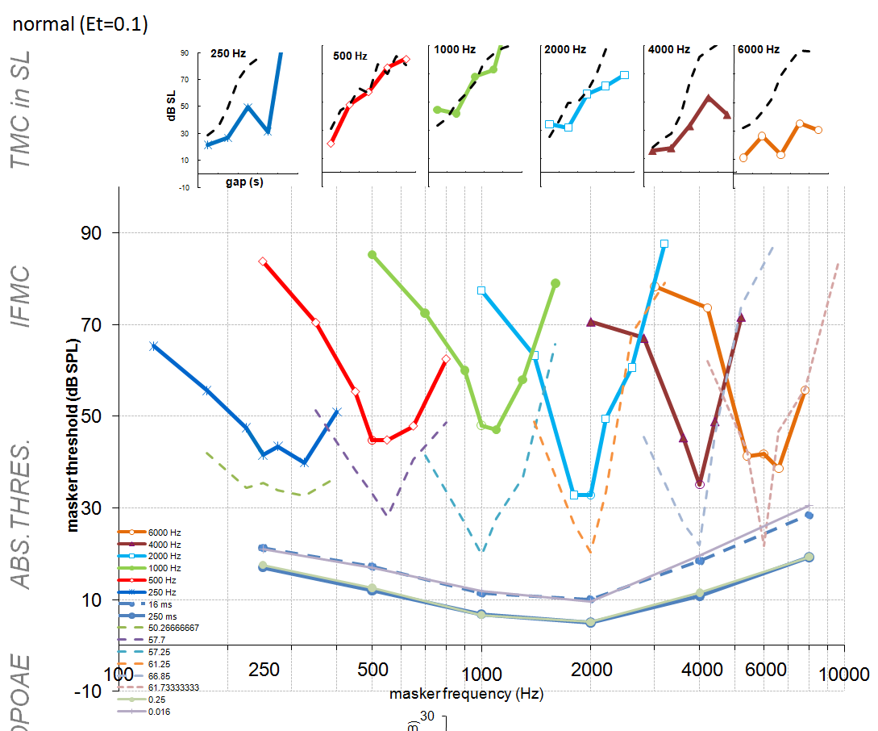

It s strengths are
- Thresholds are in the normal region and show raised values at very low and very high frequencies. The lowest thresholds are around 2 kHz
- Thresholds at 16 ms and 250 ms are well separated and parallel. The mean difference is 6 dB which is normal
- Tuning curves are a reasonable approximation to CMa (dotted lines) who has excellent hearing
- TMCs are satisfyingly steep for 500-2000 Hz probes.
Its weaknesses are
- 8 kHz tuning has a flaky tip but this may be a random error.
- TMC at 8 kHz is flat. This is because the masker is too strong and is able to mask the probe at masker levels that are still in the linear region.
- The tuning curves are very high. Ideally, they should be just a few dB above the 16 threshold function. This means that the maskers are too weak. (This is the opposite problem from 8 kHz TMC. Also the 8 kHz TMC is located at a reasonable height above the 16 ms threshold function.)
The physiological profile is as follows
BM
NB. AR functions (red lines in bottom panel) are underestimates because a single channel model was used to evaluate the BM response.
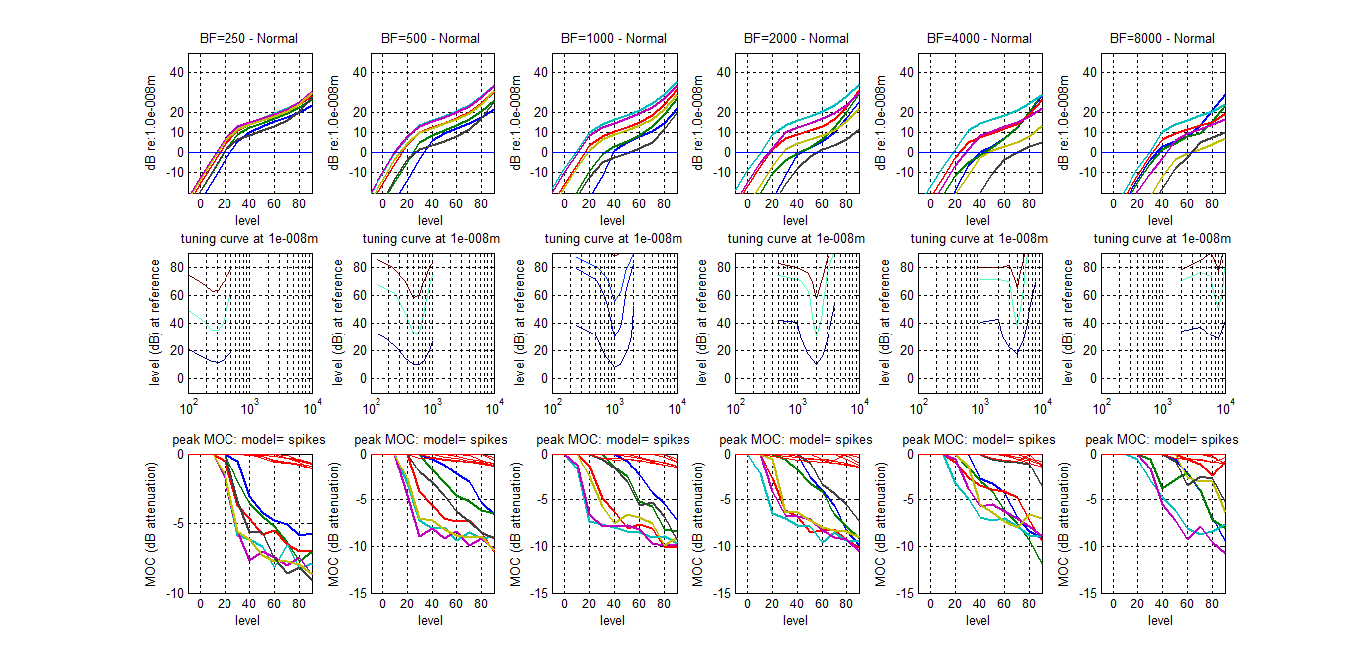
Its strengths are
- The compression threshold is about 15 dB above threshold (or, at least, 15 dB above the 10 nm peak displacement which is the target displacement at threshold).
- BF shifts can be clearly seen at 8 kHz.
- Iso-displacement tuning curves look healthy at 10 nm (lowest blue line in middle panels)
- MOC efferent attenuation also looks healthy at around 10 dB max (at CF). There is room to increase this if necessary.
Its weaknesses are
- No sign of linear response for off-BF probes. The relative frequencies are [0.25 .5 .75 1 1.25 1.5 2]. This should be checked against the animal data. I
- The iso-displacement tuning curves become narrower at higher displacement criteria (upper two curves in middle row). I would have expected them to be wider. This may be linked to previous weakness.
Other physiological indicators (here mainly at 1 kHz)
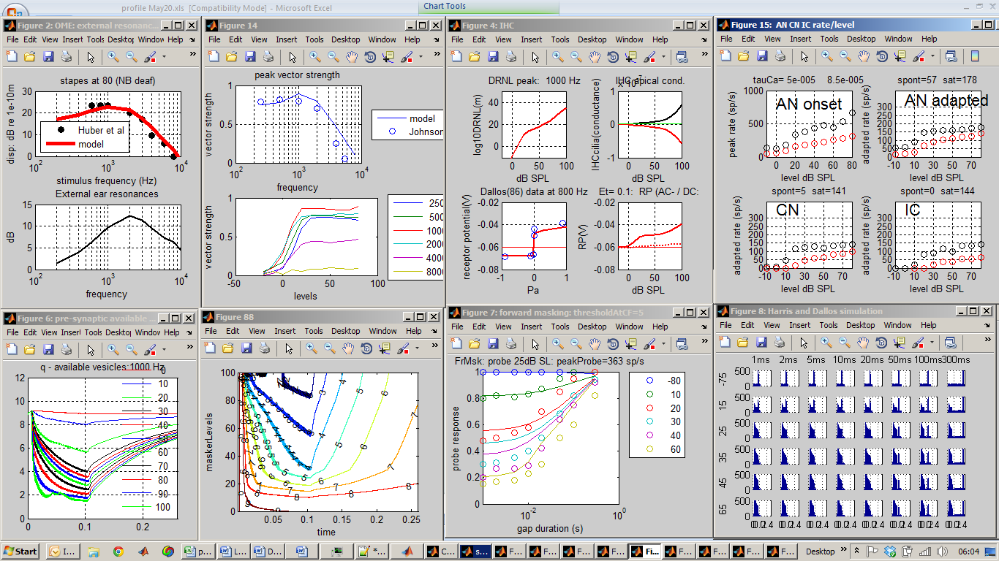
It’s strengths are
- Good phase locking (possibly a little too high at higher frequencies).
- Good match to animal forward masking data (bottom left two panels, circles are animal data). Possibly the best to date.
- HSR fibers show narrow dynamic range while HSR has wide range.
It’s weaknesses are few but some minor niggles
- Phase locking might be too high at higher frequencies. This can be adjusted by accepting a physiologically less plausible capacitance for the IHC (currently 1 pF; ELP has 8 pF).
- The receptor potential is very small (<20 mV above resting at 100 dB SPL).

Parameters

inputStimulusParams.sampleRate= | 44100
OMEParams.externalResonanceFilters= | [10 1 1000 4000]
OMEParams.OMEstapesLPcutoff= | 1000
OMEParams.stapesScalar= | 4.50E-08
OMEParams.rateToAttenuationFactor= | 0.003
OMEParams.rateToAttenuationFactorProb= | 0.005
OMEParams.ARtau= | 0.05
OMEParams.ARdelay= | 0.01
OMEParams.ARrateThreshold= | 0
DRNLParams.BFlist= | 8000
DRNLParams.a= | 30000
DRNLParams.b= | 8.00E-06
DRNLParams.c= | 0.2
DRNLParams.nonlinCFs= | 8000
DRNLParams.nonlinOrder= | 3
DRNLParams.nlBWs= | 2486
DRNLParams.p= | 0.2895
DRNLParams.q= | 170
DRNLParams.g= | 100
DRNLParams.linCFs= | 6025.93
DRNLParams.linOrder= | 3
DRNLParams.linBWs= | 5324.8
DRNLParams.MOCdelay= | 0.01
DRNLParams.rateToAttenuationFactor= | 0.009
DRNLParams.rateToAttenuationFactorProb= | 0.002
DRNLParams.MOCtau= | 0.03
DRNLParams.MOCrateThreshold= | 50
IHC_cilia_RPParams.tc= | 0.0003
IHC_cilia_RPParams.C= | 0.05
IHC_cilia_RPParams.u0= | 5.00E-09
IHC_cilia_RPParams.s0= | 3.00E-08
IHC_cilia_RPParams.u1= | 1.00E-09
IHC_cilia_RPParams.s1= | 1.00E-09
IHC_cilia_RPParams.Gmax= | 5.00E-09
IHC_cilia_RPParams.Ga= | 1.00E-09
IHC_cilia_RPParams.Cab= | 1.00E-12
IHC_cilia_RPParams.Et= | 0.1
IHC_cilia_RPParams.Gk= | 2.00E-08
IHC_cilia_RPParams.Ek= | -0.08
IHC_cilia_RPParams.Rpc= | 0.04
IHCpreSynapseParams.GmaxCa= | 1.20E-08
IHCpreSynapseParams.ECa= | 0.066
IHCpreSynapseParams.beta= | 400
IHCpreSynapseParams.gamma= | 100
IHCpreSynapseParams.tauM= | 5.00E-05
IHCpreSynapseParams.power= | 3
IHCpreSynapseParams.z= | 2E+42
IHCpreSynapseParams.tauCa= | [5e-005 8.5e-005]
AN_IHCsynapseParams.M= | 12
AN_IHCsynapseParams.y= | 6
AN_IHCsynapseParams.x= | 60
AN_IHCsynapseParams.l= | 250
AN_IHCsynapseParams.r= | 500
AN_IHCsynapseParams.refractory_period= | 0.00075
AN_IHCsynapseParams.numFibers= | 100
AN_IHCsynapseParams.TWdelay= | 0.004
MacGregorMultiParams.nNeuronsPerBF= | 10
MacGregorMultiParams.type= | 'chopper cell'
MacGregorMultiParams.fibersPerNeuron= | 10
MacGregorMultiParams.dendriteLPfreq= | 50
MacGregorMultiParams.currentPerSpike= | 3.50E-08
MacGregorMultiParams.Cap= | 1.67E-08
MacGregorMultiParams.tauM= | 0.002
MacGregorMultiParams.Ek= | -0.01
MacGregorMultiParams.dGkSpike= | 0.000133
MacGregorMultiParams.tauGk= | 0.0001
MacGregorMultiParams.Th0= | 0.01
MacGregorMultiParams.c= | 0
MacGregorMultiParams.tauTh= | 0.02
MacGregorMultiParams.Er= | -0.06
MacGregorMultiParams.Eb= | 0.06
MacGregorMultiParams.PSTHbinWidth= | 0.0001
MacGregorParams.type= | 'chopper cell'
MacGregorParams.fibersPerNeuron= | 10
MacGregorParams.dendriteLPfreq= | 100
MacGregorParams.currentPerSpike= | 1.20E-07
MacGregorParams.Cap= | 1.67E-08
MacGregorParams.tauM= | 0.002
MacGregorParams.Ek= | -0.01
MacGregorParams.dGkSpike= | 0.000133
MacGregorParams.tauGk= | 0.0003
MacGregorParams.Th0= | 0.01
MacGregorParams.c= | 0
MacGregorParams.tauTh= | 0.02
MacGregorParams.Er= | -0.06
MacGregorParams.Eb= | 0.06
MacGregorParams.debugging= | 0
MacGregorParams.wideband= | 0

MAP parameters (strial presbyacusis – reduced endocochlear potential).
When the endocochlear potential in the ‘Normal’ model is reduced from 0.1V to 0.07V we get the following profile.
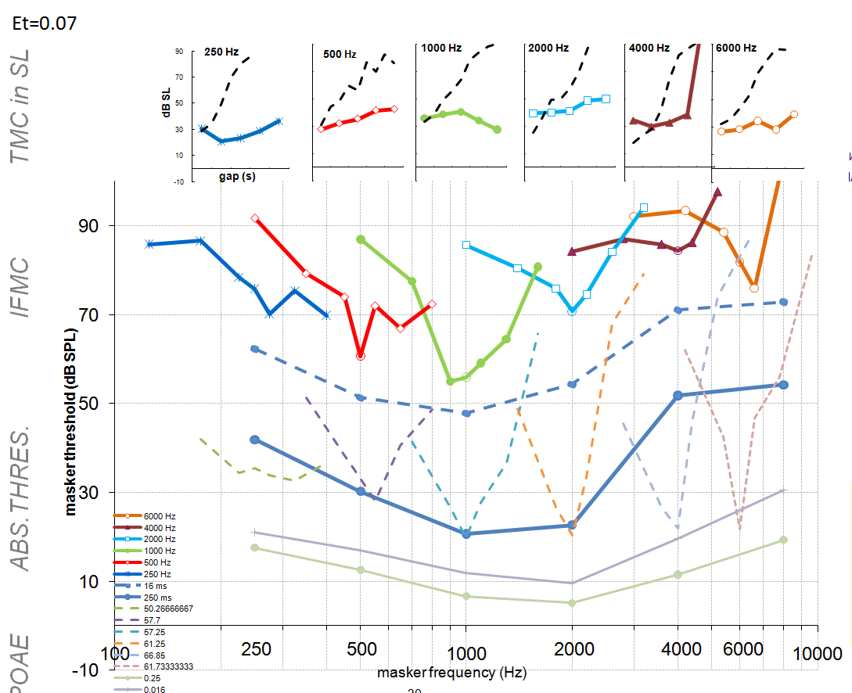
Its strengths are
- Raised thresholds
- Wider tuning than normal but still clearly tuned.
Its weaknesses are
- Surprisingly increased gap between 250 and 16 ms absolute thresholds. This most likely caused by the relationship between absolute thresholds and the compression threshold. For this group the compression threshold is unchanged from normal. At 2 kHz the threshold is around 30 dB SPL. This puts the 250 ms probe below the compression threshold with the 16 ms probe above the compression threshold.
- Flat TMCs when a gentle slope is expected.
- Only limited sign of a high-frequency loss.
For smaller reduction in ET from 0.1V to 0.08V we get
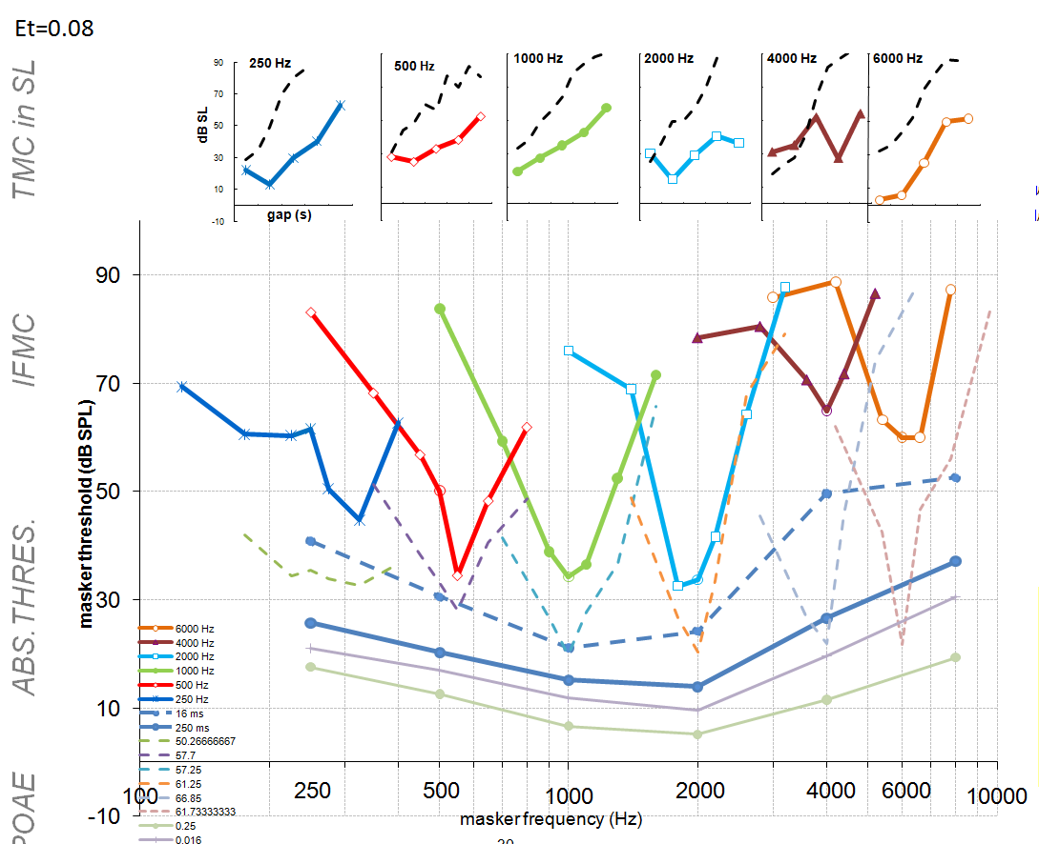
Its strengths are gently sloping TMCs showing only limited loss of compression and some sign of HF-loss (but not much). Its weakness are mainly down to the small rise in threshold.
MAP parameters – loss of OHC function(setting DRNLa= 0)
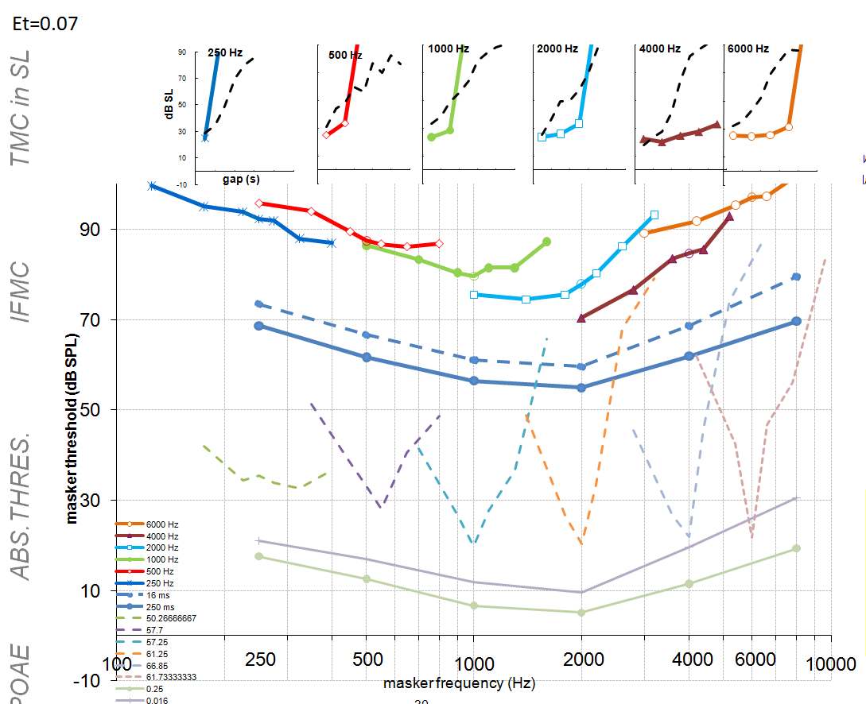
It’s strengths are
- Raised thresholds. 50 dB loss is typical of this group
- Loss of tuning
It’s weaknesses are
- TMCs are not well defined because maskers need to be close to or above 100 dB SPL (ignore points off the graph; I am having trouble with Excel)
- Gap between 16 and 250 ms abs thresholds is the same as normal and it should be smaller.
If the reduction in DRNLa is less severe (DRNLa= 300) we get
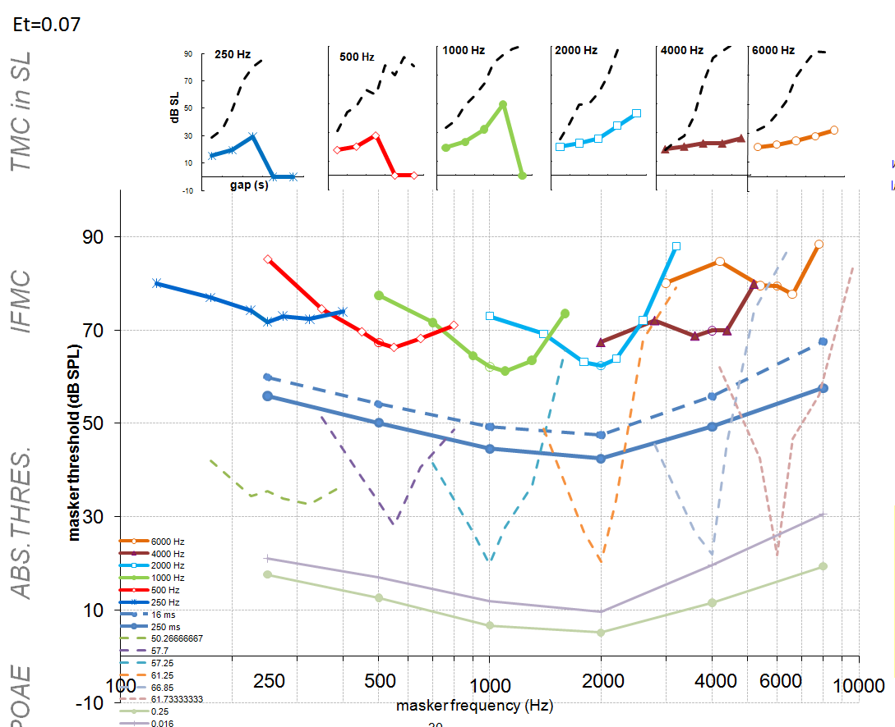
Its strengths are
- Flat TMCs at 4 and 8 kHz. Shallow TMCs elsewhere.
- Shallow tuning
Its weaknesses are
- TMCs not flat enough.

